**MONARK UNIVERSITY**

**FACULTY OF COMPUTER APPLICATION**



MASTER OF COMPUTER APPLICATIONS

SEMSTER –IV

2023-24

MAJOR PROJECT/INTERNSHIP

**Hospital Management System**

**Guided By:**

Prof. Nidhi Panchal

**Prepared By:**

Student Name:Chauhan Chirag Sureshbhai

Enrolment No : 22162100010002

**Company Certificate**

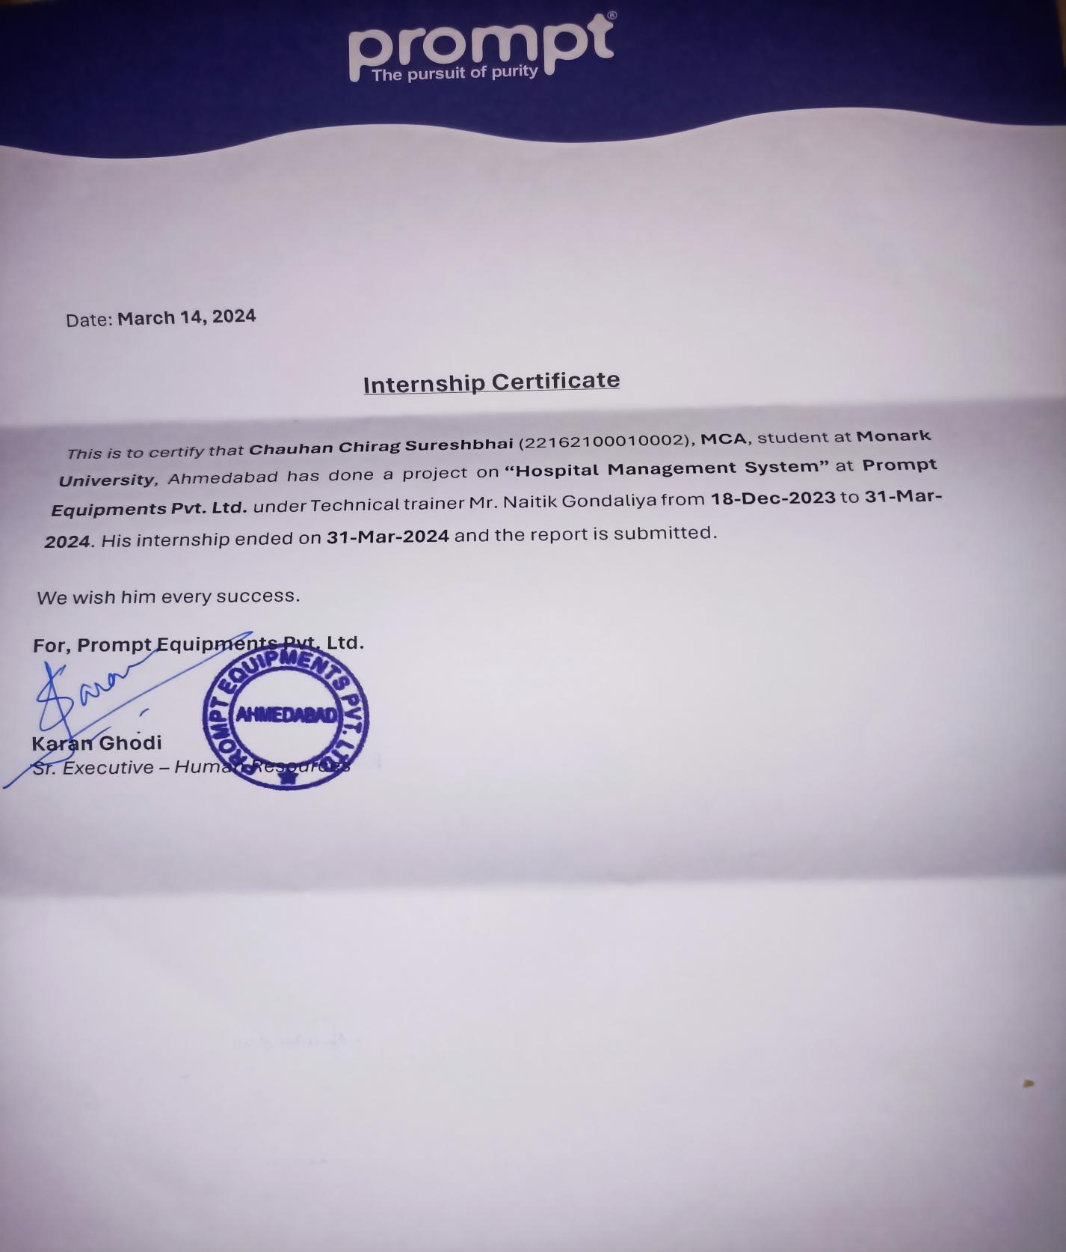

**College Certificate**

## **MONARK UNIVERSITY**

**FACULTY OF COMPUTER APPLICATION**

[April/May-2024]

# 

## This is to certify that this project entitled **“Hospital Management System”** is carried out by **Chauhan Chirag** Studying in 4th Semester-Master of Computer Applications (Faculty of Computer Applications, Vahelal) for partial fulfillment Master of Computer Applications degree to be awarded by Monark University.

This project work has been carried out under faculty Guidance. The project is fit to the considered at for evolution for the degree of Master of Computer Applications.

**Place:** Vahelal

**Date:** 20 - March - 24

# Guide Name: Principal Name:

# Prof. Nidhi Panchal Prof. Sudha Patel

**Acknowledgement**

The success and the final outcome of this project required a lot of guidance and assistance from many people and we are extremely fortunate to have got this all along the completion of our project work. Whatever we have done is only due to such guidance and assistance and we would not forget to thank them.

We owe our profound gratitude to our project guide**, Prof.Nidhi Panchal, Assistant Professor, Faculty of Computer Applications** who took keen interest in our project work and provided his knowledge insights and guidance all along.

We heart-fully thank **Prof. Sudha Patel, Dean of Faculty of Computer Applications** for her unlisted encouragement and support throughout.

Last but not least, we also thank **Naitik Gondaliya(Trainer), PromptSoftech pvt.ltd,** for giving us an opportunity to do the project work. We are extremely grateful to her for providing support and guidance to us even though she had busy schedule managing the company affairs.

**Table of Contents**

|  |  |  |  |
| --- | --- | --- | --- |
| **Sr.No.** | **Content** | | **Page No.** |
| 1 | Introduction | | 1 |
|  | 1.1 | Existing System | 2 |
|  | 1.2 | Need for the New System | 3 |
|  | 1.3 | Objective of the New System | 4 |
|  | 1.4 | Problem Definition | 6 |
|  | 1.5 | Core Components | 7 |
|  | 1.6 | Project Profile | 9 |
|  | 1.7 | Assumptions and Constraints | 12 |
|  | 1.8 | Advantages and Limitations of the Proposed system | 14 |
| 2 | Requirement Determination & Analysis | |  |
|  | 2.1 | Requirement Determination | 16 |
|  | 2.2 | Targeted Users | 19 |
| 3 | System Design | |  |
|  | 3.1 | Use Case Diagram | 22 |
|  | 3.2 | Class Diagram | 23 |
|  | 3.3 | Interaction Diagram | 24 |
|  | 3.4 | Activity Diagram | 25 |
|  | 3.5 | Data Dictionary | 26 |
| 4 | Development | |  |
|  | 4.1 | Coding Standards | 32 |
|  | 4.2 | Screen Shots | 38 |
| 5 | Proposed Enhancements | | 46 |
| 6 | Conclusion | | 48 |
| 7 | Bibliography | | 49 |

1) . Introduction

**1.1). Existing System :**

**Time-Consuming Paper-Based Reporting :**

* One of the primary issues with our current hospital management system is the extensive use of paper for reporting purposes. This manual process is incredibly time-consuming, leading to delays in accessing critical information and hindering the efficiency of our operations. Staff members spend a significant amount of time compiling, sorting, and storing paper records, which could be better utilized for patient care and other essential tasks.

**Lack of Transparency :**

* Additionally, the reliance on paper-based reporting results in a lack of transparency within our hospital management system. With records scattered across various departments and locations, it becomes challenging to maintain visibility and accountability. This opacity not only hampers decision-making processes but also increases the risk of errors and discrepancies in our data.

**Inability to Maintain Records :**

* The current system's reliance on paper makes it difficult to maintain accurate and up-to-date records. Paper documents are prone to damage, loss, or misplacement, jeopardizing the integrity and completeness of our data. Moreover, retrieving historical records or tracking changes over time becomes a daunting task, further exacerbating the inefficiencies of our system.

**In light of these challenges, I propose that we undertake a comprehensive project to modernize our hospital management system. This project will involve the following key components:**

* **Transition to Digital Reporting**
* **Implementation of Transparent Practices**
* **Adoption of Electronic Health Records (EHR)**
* **Training and Change Management**

1

**1.2). Need For The New System :**

* Our current system is plagued with inefficiencies and limitations that impede our ability to deliver high-quality patient care and operate effectively. Below are the key reasons why we require an immediate transition to a new system.
* **Time Inefficiency and Resource Drain** : Our existing hospital management system relies heavily on manual processes and paper-based documentation, resulting in significant time inefficiencies and resource drain. Staff members spend countless hours inputting, organizing, and retrieving data, detracting from their primary focus on patient care. This inefficiency not only compromises productivity but also increases the risk of errors and delays in decision-making.
* **Lack of Real-time Accessibility** : The current system's reliance on paper records and fragmented data storage makes it challenging to access critical information in real-time. This lack of accessibility hampers communication and coordination among healthcare providers, leading to delays in treatment and potentially compromising patient outcomes. In today's fast-paced healthcare environment, the ability to access up-to-date information promptly is paramount to delivering timely and effective care.
* **Inadequate Data Security and Compliance** : Paper-based systems are inherently vulnerable to security breaches, loss, and unauthorized access. Our current system lacks robust data security measures, putting sensitive patient information at risk of exposure. Furthermore, maintaining compliance with regulatory requirements such as HIPAA (Health Insurance Portability and Accountability Act) becomes increasingly challenging in the absence of proper data security protocols. A new HMS equipped with advanced security features is essential to safeguarding patient confidentiality and ensuring compliance with regulatory standards.
* **Limited Analytical Capabilities** : The inability to analyze and leverage data effectively is a significant limitation of our current system. Without comprehensive analytical capabilities, we are unable to extract valuable insights from patient data, identify trends, or make data-driven decisions to improve operational efficiency and patient outcomes. A modern HMS equipped with robust analytic and reporting functionalities is essential for driving continuous improvement and innovation within our healthcare facility.

2

* **Enhanced Patient Experience** : Ultimately, the adoption of a new hospital management system is crucial for enhancing the overall patient experience. By streamlining administrative processes, improving data accessibility, and ensuring the security of patient information, we can deliver more personalized, efficient, and high-quality care to our patients. A patient-eccentric approach is at the core of our mission, and investing in a new HMS is a pivotal step toward fulfilling that commitment.
* In light of these compelling reasons, I propose that we prioritize the implementation of a new hospital management system as a strategic initiative for our healthcare facility. This endeavor will require collaboration, dedication, and investment, but the long-term benefits in terms of improved efficiency, patient care, and organizational performance will far outweigh the initial challenges.

3

**1.3). Objective of the New System :**

As we embark on the journey of implementing a new hospital management system (HMS) within our healthcare facility, it's essential to clearly outline the objectives that we aim to achieve through this trans-formative initiative. Below are the key objectives of the new system:

* **Enhanced Efficiency and Productivity** : The primary objective of implementing the new HMS is to enhance the efficiency and productivity of our healthcare facility. By streamlining administrative processes, automating routine tasks, and eliminating manual paperwork, we aim to optimize resource utilization and minimize time wastage, allowing our staff to focus more on delivering high-quality patient care.
* **Improved Patient Care and Safety** : A fundamental goal of the new HMS is to improve patient care and safety. Through better access to patient information, streamlined communication among healthcare providers, and advanced clinical decision support tools, we aim to enhance the quality, accuracy, and timeliness of patient care delivery, ultimately leading to better health outcomes and increased patient satisfaction.
* **Real-time Access to Information** : The new HMS will provide real-time access to comprehensive patient data, enabling healthcare providers to make informed clinical decisions promptly. By eliminating the reliance on paper-based records and implementing electronic health records (EHR), we aim to ensure that critical patient information is readily available whenever and wherever it is needed, facilitating seamless continuity of care.
* **Enhanced Data Security and Compliance** : Another objective of the new HMS is to enhance data security and ensure compliance with regulatory requirements such as HIPAA. By implementing robust security measures, encryption protocols, and access controls, we aim to safeguard sensitive patient information from unauthorized access, breaches, or data loss, thereby protecting patient confidentiality and maintaining trust.

4

* **Empowerment of Patients and Caregivers** : The new HMS will empower patients and caregivers by providing them with greater access to their health information and facilitating active participation in their care journey. Through patient portals, medicine capabilities, and personalized health records, we aim to engage patients in shared decision-making, promote health literacy, and foster collaborative relationships between patients and healthcare providers.
* **Facilitation of Data-driven Decision-making** : The new HMS will serve as a valuable tool for facilitating data-driven decision-making and performance improvement initiatives within our healthcare facility. By providing robust analytic, reporting dashboards, and key performance indicators (Kips), we aim to enable stakeholders to monitor, analyze, and optimize various aspects of hospital operations, identify areas for improvement, and drive continuous quality improvement.
* In summary, the objectives of implementing the new hospital management system are centered around enhancing efficiency, improving patient care, ensuring data security and compliance, empowering patients, and facilitating data-driven decision-making. Through the successful realization of these objectives, we aspire to transform our healthcare facility into a model of excellence and innovation in patient-centered care.

5

**1.4).** **Problem Definition :**

* it's crucial to define the problem statement that necessitates this trans-formative initiative. Below, I outline the key challenges and shortcomings of our current system:
* **Inefficiency and Time-Consumption** : Our current hospital management system heavily relies on manual processes and paper-based documentation, leading to inefficiencies and time wastage. Staff members spend significant amounts of time inputting, organizing, and retrieving data, detracting from their ability to focus on patient care and other critical tasks.
* **Lack of Real-time Access to Information** : The reliance on paper records and fragmented data storage makes it challenging to access critical information in real-time. This lack of accessibility hampers communication and coordination among healthcare providers, leading to delays in treatment and potentially compromising patient outcomes.
* **Data Security Vulnerabilities** : The current system's lack of robust data security measures exposes sensitive patient information to security breaches, unauthorized access, and data loss. Without proper encryption protocols and access controls in place, patient confidentiality is at risk, undermining trust and compliance with regulatory standards such as HIPAA.
* **Limited Analytical Capabilities** : The inability to analyze and leverage data effectively is a significant limitation of our current system. Without comprehensive analytical capabilities, we are unable to extract valuable insights from patient data, identify trends, or make data-driven decisions to improve operational efficiency and patient outcomes.
* **Patient Experience and Engagement** : The current system fails to adequately engage patients and empower them to take an active role in their care journey. Limited access to health information, fragmented communication channels, and lack of personalized care options contribute to sub optimal patient experiences and reduced satisfaction levels.
* **Compliance Challenges** : Maintaining compliance with regulatory requirements such as HIPAA is increasingly challenging in the absence of proper data security protocols and documentation practices. Non-compliance poses legal and financial risks to our healthcare facility and erodes trust among patients and stakeholders.

6

6

* In light of these challenges, the problem statement for our hospital management system modernization initiative can be defined as follows:
* "The current hospital management system is inefficient, outdated, and poses significant risks to patient care, data security, and regulatory compliance. There is an urgent need to transition to a modern, digital HMS that streamlines processes, enhances data accessibility and security, improves patient engagement, and enables data-driven decision-making to ensure high-quality, safe, and patient-centered care."
* **1.5).** **Core Components:**
* **Electronic Health Records (EHR) :**
* The EHR module will serve as the central repository for comprehensive patient health information, including medical history, treatment plans, medication records, lab results, and diagnostic images.
* It will facilitate real-time access to patient records, enabling healthcare providers to make informed clinical decisions promptly.
* Advanced features such as interoperability with other healthcare systems, decision support tools, and customization templates will enhance usability and efficiency.
* Administrative and Billing Management:

**Clinical Decision Support System (CDSS) :**

* The CDSS will provide evidence-based clinical guidelines, alerts, and reminders to assist healthcare providers in making informed treatment decisions.
* It will analyze patient data, medical history, and best practices to recommend appropriate diagnostic tests, medications, and treatment protocols.
* The CDSS will help reduce medical errors, improve patient safety, and standardize care delivery across the healthcare facility.

7

**Data Analytic and Reporting :**

* This component will enable data-driven decision-making by providing robust analytic, reporting dashboards, and key performance indicators (Kips).
* It will analyze clinical and operational data to identify trends, monitor outcomes, and optimize resource allocation.
* Customization reports and visualizations will empower stakeholders to track performance metrics, measure progress towards goals, and drive continuous improvement initiatives.

**Patient Engagement Tools :**

* Patient engagement tools such as patient portals, mobile applications, and medicine capabilities will empower patients to take an active role in their care.
* These tools will provide patients with access to their health information, appointment scheduling, medication reminders, and secure communication channels with healthcare providers.
* By promoting transparency, communication, and collaboration, patient engagement tools will enhance the overall patient experience and satisfaction levels.

8

**1.6).** **Project Profile:**

**Project Overview :**

The Hospital Management System Modernization Project aims to address the inefficiencies and limitations of the current hospital management system (HMS) by implementing a modern, digital solution. This trans-formative initiative will streamline administrative processes, enhance patient care delivery, improve data security and compliance, and empower stakeholders with advanced analytic and decision support capabilities.

**Project Objectives:**

* Enhance Efficiency: Streamline administrative processes and automate routine tasks to optimize resource utilization and minimize time wastage.
* Improve Patient Care: Enhance the quality, accuracy, and timeliness of patient care delivery through better access to patient information, streamlined communication, and clinical decision support tools.
* Ensure Data Security and Compliance: Implement robust security measures and ensure compliance with regulatory requirements such as HIPAA to safeguard patient data and maintain trust.
* Empower Patients and Caregivers: Provide patients and caregivers with greater access to health information, personalized care options, and opportunities for active participation in the care journey.
* Facilitate Data-driven Decision-making: Enable stakeholders to make informed decisions by providing robust analytic, reporting dashboards, and key performance indicators (Kips) for monitoring and optimizing hospital operations.

9

**Project Components:**

* Electronic Health Records (EHR): Implement a centralized repository for patient health information, facilitating real-time access and seamless continuity of care.
* Administrative and Billing Management: Streamline administrative processes such as patient registration, appointment scheduling, and billing to optimize revenue cycle management.
* Clinical Decision Support System (CDSS): Provide evidence-based clinical guidelines, alerts, and reminders to assist healthcare providers in making informed treatment decisions.

**Data Analytic and Reporting:**

* Enable data-driven decision-making by providing robust analytic, reporting dashboards, and Kips for monitoring performance and driving continuous improvement initiatives.
* Patient Engagement Tools: Empower patients with access to health information, appointment scheduling, medication reminders, and secure communication channels with healthcare providers.
* Security and Compliance Features: Implement encryption, access controls, audit trails, and regular security updates to safeguard patient data and ensure compliance with regulatory requirements.

10

**Technical Challenges:**

* Potential delays or complications in system development and integration.
* Adoption Resistance: Resistance from staff members to adapt to new processes and technologies.
* Data Security Risks: Security breaches or data loss incidents compromising patient confidentiality.
* Regulatory Compliance: Failure to meet regulatory requirements leading to legal and financial consequences.

**Conclusion:**

* The Hospital Management System Modernization Project represents a strategic initiative to transform our healthcare facility into a model of excellence and innovation. By implementing a modern, digital solution, we aim to enhance efficiency, improve patient care, ensure data security and compliance, and empower stakeholders with advanced analytic and decision support capabilities.

11

1.7). **Assumptions and Constraints :**

**Assumptions:**

* **Budget Availability:** The availability of sufficient budgetary resources for the project is assumed, including funding for software development, hardware infrastructure, training, and ongoing support and maintenance.
* **Access to Skilled Resources:** It is assumed that the project team will have access to skilled resources, including IT specialists, healthcare professionals, training specialists, and compliance officers, to execute the project successfully.
* **Regulatory Compliance:** The project assumes that all regulatory requirements, such as HIPAA and other data privacy regulations, will be adequately addressed and complied with throughout the implementation process.
* **Timely Decision-Making**: It is assumed that timely decisions will be made by project stakeholders to resolve issues, provide guidance, and approve key deliverable to ensure project progress according to the timeline.

**Constraints:**

* **Time Constraints:** The project is constrained by a fixed timeline, requiring completion within the designated time frame to minimize disruption to hospital operations and ensure timely realization of project benefits.
* **Resource Limitations:** There may be limitations in terms of human resources, expertise, and availability of skilled personnel, which could impact the speed and scope of project execution.

12

* **Legacy System Integration:** The project may face constraints related to the integration of the new HMS with existing legacy systems, requiring careful planning and coordination to ensure seamless data migration and interoperability.
* **Change Management:** Resistance to change among staff members and stakeholders may pose constraints on the adoption and acceptance of the new HMS, necessitating effective change management strategies and communication plans.
* **Data Migration Challenges:** The migration of data from the existing system to the new HMS may present technical challenges, including data cleansing, transformation, and validation, which could impact project timelines and resource requirements.

By acknowledging these assumptions and constraints, the project team can proactively plan, mitigate risks, and devise strategies to address potential challenges, ensuring the successful implementation of the HMS modernization project.

13

**1.8). Advantages and Limitations of the Proposed system :**

* **Enhanced Efficiency:** The proposed system will streamline administrative processes, automate routine tasks, and optimize resource utilization, leading to increased efficiency and productivity within the healthcare facility.
* **Improved Patient Care:** With real-time access to comprehensive patient health information, clinical decision support tools, and streamlined communication channels, healthcare providers can deliver more personalized, timely, and effective care to patients.
* **Enhanced Data Security:** Robust security measures, encryption protocols, and access controls will safeguard sensitive patient information, ensuring confidentiality, integrity, and compliance with regulatory requirements such as HIPAA.
* **Better Decision-making:** Advanced analytic, reporting dashboards, and key performance indicators (Kips) will enable stakeholders to make informed, data-driven decisions, monitor performance, and drive continuous improvement initiatives.
* **Empowered Patients:** Patient engagement tools such as patient portals, mobile applications, and medicine capabilities will empower patients to take an active role in their care journey, promoting transparency, communication, and collaboration.
* **Scalability and Flexibility:** The proposed system will be designed to scale with the growing needs of the healthcare facility and adapt to changes in healthcare regulations, technology advancements, and patient demographics.

14

**Limitations of the Proposed System:**

* **Initial Investment**: Implementing the proposed system will require significant upfront investment in software development, hardware infrastructure, training, and ongoing support and maintenance, which may pose financial challenges for the healthcare facility.
* **Adoption Challenges:** Resistance to change among staff members and stakeholders, coupled with the learning curve associated with new technologies, may hinder the adoption and acceptance of the proposed system, impacting its effectiveness and success.
* **Integration Complexity:** Integrating the new HMS with existing legacy systems, data migration, and interoperability challenges may pose technical complexities and require careful planning, coordination, and testing to ensure seamless integration and data consistency.
* **Data Security Risks:** Despite robust security measures, the proposed system may still be vulnerable to security breaches, data loss incidents, or unauthorized access, which could compromise patient confidentiality and trust in the healthcare facility.
* **Training and Support Needs:** Adequate training and support will be essential to ensure that staff members are proficient in using the new system and can effectively leverage its features and functionalities to improve patient care and operational efficiency.
* **Maintenance Requirements:** Ongoing support and maintenance of the proposed system will be necessary to address software updates, security patches, technical issues, and evolving user requirements, requiring dedicated resources and budget allocation.

15

2) . Requirement Determination & Analysis

**2.1) Requirement Determination**

Requirement determination is a critical phase in the development of any software system, including a hospital management system (HMS). It involves identifying, analyzing, documenting, and validating the needs and expectations of stakeholders to ensure that the system meets their requirements effectively. Here's a structured approach to requirement determination for an HMS:

**Stakeholder Identification:**

* Identify all stakeholders involved in the HMS project, including hospital administrators, healthcare professionals (doctors, nurses, etc.), administrative staff, IT specialists, patients, and regulatory authorities.

**Gather User Requirements:**

* Conduct interviews, surveys, focus groups, and workshops with stakeholders to gather user requirements.
* Identify pain points, challenges, and opportunities for improvement in the current hospital management processes.
* Document functional requirements (features and functionalities) and non-functional requirements (performance, security, usability, etc.) based on stakeholder inputs.

**Analyze Business Processes:**

* Analyze existing hospital workflows and business processes to understand how the new HMS can streamline operations and improve efficiency.
* Identify key areas for automation, integration, and optimization to enhance patient care delivery and administrative tasks.

16

**Regulatory Compliance Requirements:**

* Identify and document regulatory requirements and standards that the new HMS must comply with, such as HIPAA, GDPR, and local healthcare regulations.
* Ensure that the system architecture, data security measures, and privacy policies align with regulatory requirements.

**Technology Assessment:**

* Assess the current technology infrastructure, software platforms, and IT resources available within the healthcare facility.
* Determine the compatibility of the proposed HMS with existing systems and identify any technology gaps or constraints that need to be addressed.

**Prioritize Requirements:**

* Prioritize user requirements based on their importance, urgency, and impact on patient care and operational efficiency.
* Use techniques such as MoSCoW (Must have, Should have, Could have, Won't have) prioritization to categorize requirements accordingly.

**Document Requirements:**

* Document all gathered requirements in a comprehensive requirement specification document.
* Clearly define each requirement, including its description, source, priority, acceptance criteria, and any dependencies or constraints.

17

**Validate Requirements:**

* Validate the documented requirements with stakeholders to ensure accuracy, completeness, and alignment with their needs and expectations.
* Address any discrepancies, clarifications, or changes identified during the validation process.

**Iterative Refinement:**

* Recognize that requirement determination is an iterative process and may require refinement based on feedback, changes in project scope, or evolving stakeholder needs.

Continuously review and update the requirement specification document throughout the project lifecycle.

* By following this systematic approach to requirement determination, the project team can ensure that the proposed HMS meets the needs and expectations of stakeholders, aligns with regulatory requirements, and contributes to the overall success of the project.

18

**2.2).Targeted Users**

Identifying the targeted users for a hospital management system (HMS) is crucial for designing a solution that meets their specific needs and preferences. Here are the primary categories of users typically targeted for an HMS:

**Hospital Administrators:**

* Hospital administrators oversee the overall operations and strategic direction of the healthcare facility.
* They require access to high-level administrative functionalities such as financial management, resource allocation, and performance monitoring.
* Key features for administrators may include dashboard analytic, revenue cycle management, and compliance reporting tools.

**Healthcare Professionals:**

* Healthcare professionals include doctors, nurses, surgeons, and other clinical staff responsible for patient care delivery.
* They require access to patient information, treatment plans, medication orders, and clinical decision support tools.
* Key features for healthcare professionals may include electronic health records (EHR), patient scheduling, medication management, and telemedicine capabilities.

19

**Administrative Staff:**

* Administrative staff members handle tasks such as patient registration, appointment scheduling, billing, and insurance claims processing.
* They require user-friendly interfaces for managing administrative workflows efficiently.
* Key features for administrative staff may include patient registration systems, appointment scheduling tools, billing management modules, and insurance verification functionalities.

**IT Specialists:**

* IT specialists are responsible for the maintenance, configuration, and support of the HMS software and hardware infrastructure.
* They require access to system administration tools, configuration settings, and technical support resources.
* Key features for IT specialists may include system configuration interfaces, user management modules, data backup and recovery tools, and technical documentation resources.

**Patients and Caregivers:**

* Patients and their caregivers are also important users of the HMS, as they interact with the system to access health information, schedule appointments, and communicate with healthcare providers.
* They require user-friendly interfaces and self-service functionalities to manage their healthcare needs effectively.

20

* Key features for patients and caregivers may include patient portals, mobile applications, appointment scheduling tools, medication reminders, and secure messaging platforms.

**Regulatory Authorities:**

* Regulatory authorities such as government agencies and accreditation bodies may also be considered as users of the HMS, as they require access to compliance data and reporting functionalities.
* They require tools for auditing, regulatory reporting, and monitoring compliance with healthcare regulations and standards.
* Key features for regulatory authorities may include compliance reporting modules, audit trail functionalities, and data analytic tools for regulatory oversight.
* By identifying and understanding the specific needs and preferences of these targeted user groups, the design and development of the HMS can be tailored to ensure usability, functionality, and overall user satisfaction.

21

1. **. System Design**

**3.1). Use Case Diagram**

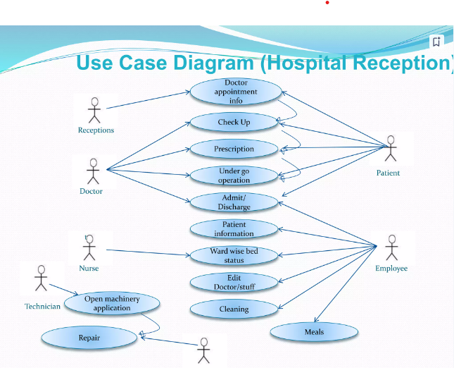

22

**3.2)Class Diagram :**

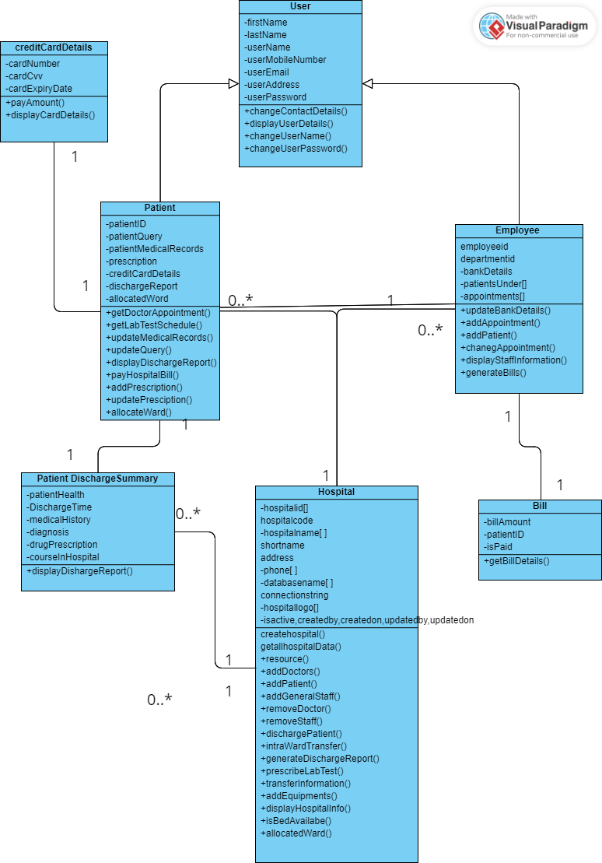

23

**3.3). Interaction Diagram**

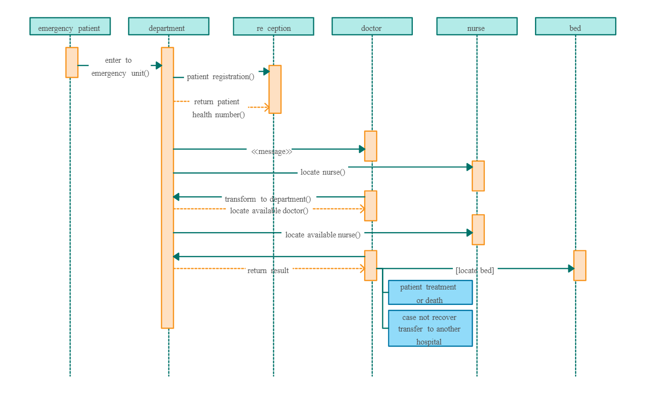

24

**3.3).Activity Diagram**

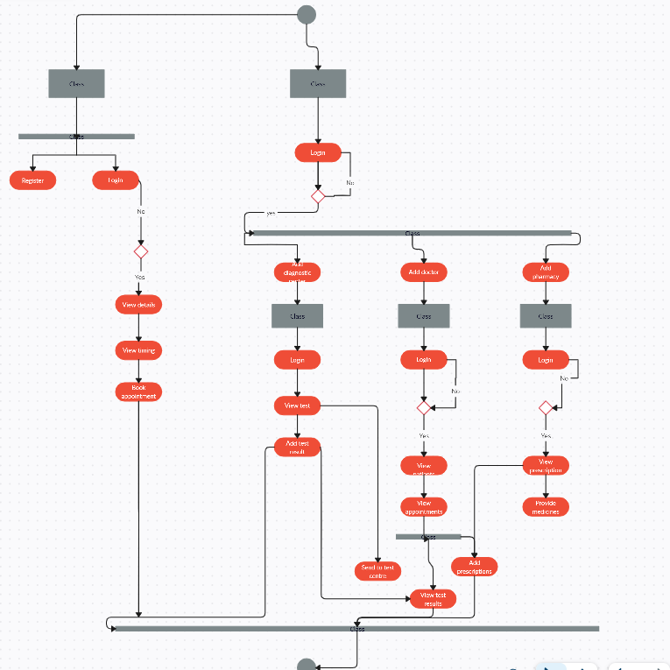

25

**3.4).Data Dictionary**

**Hospital Table :**

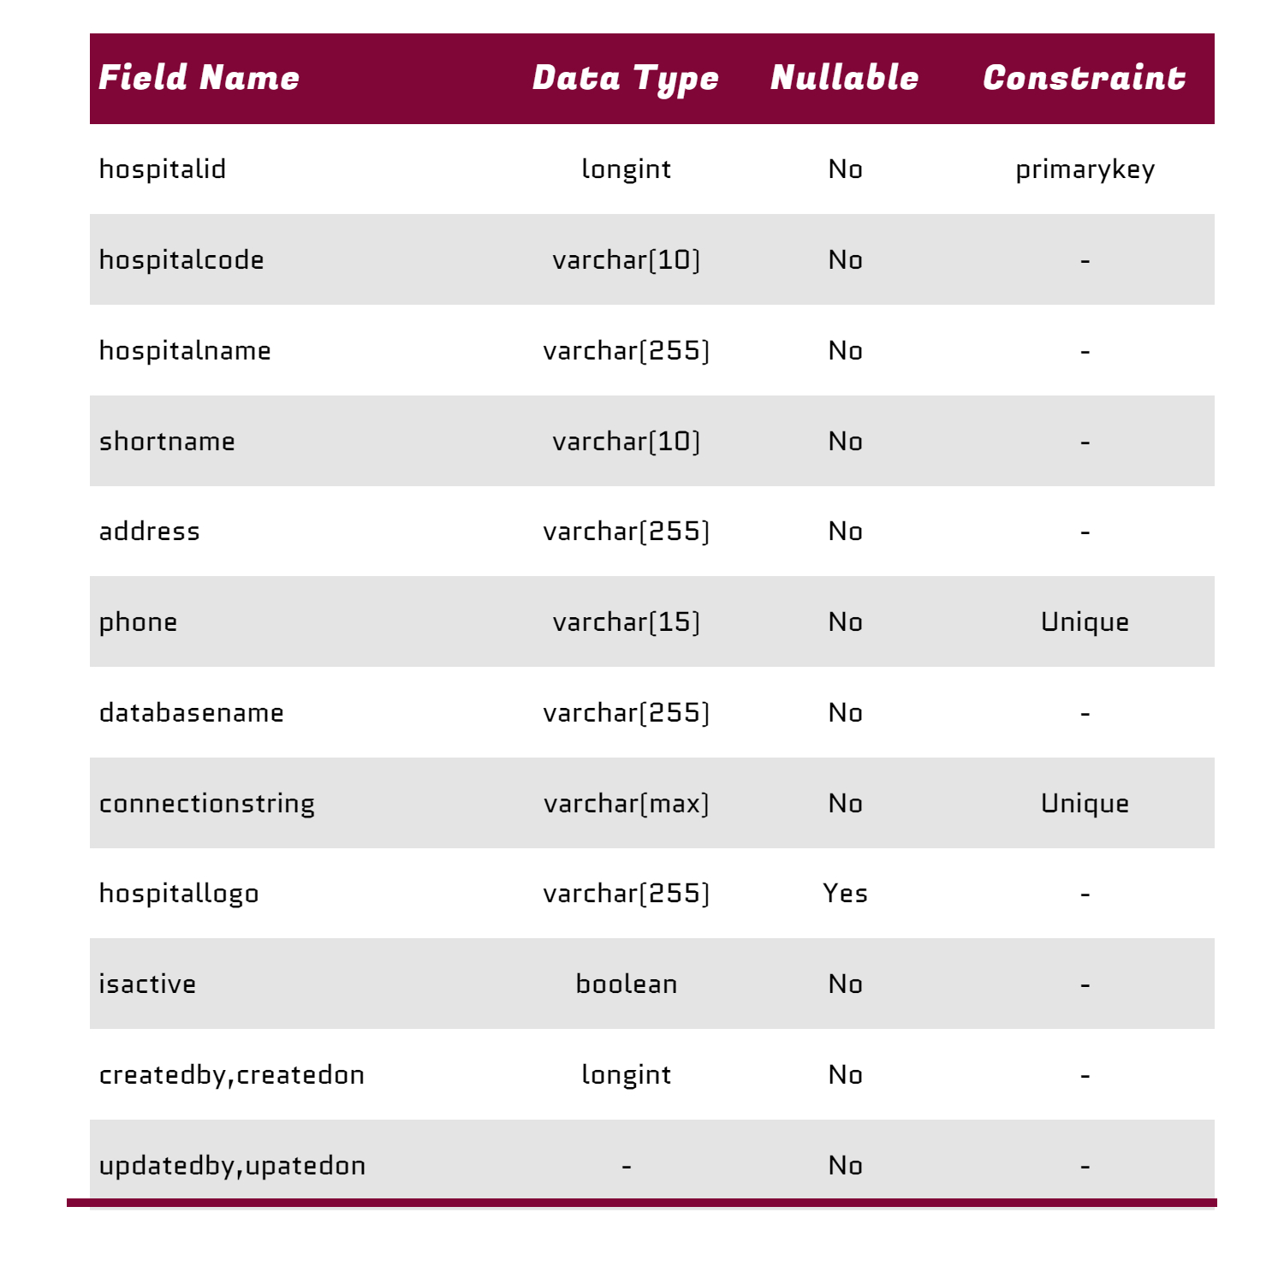

26

**Employee Table :**

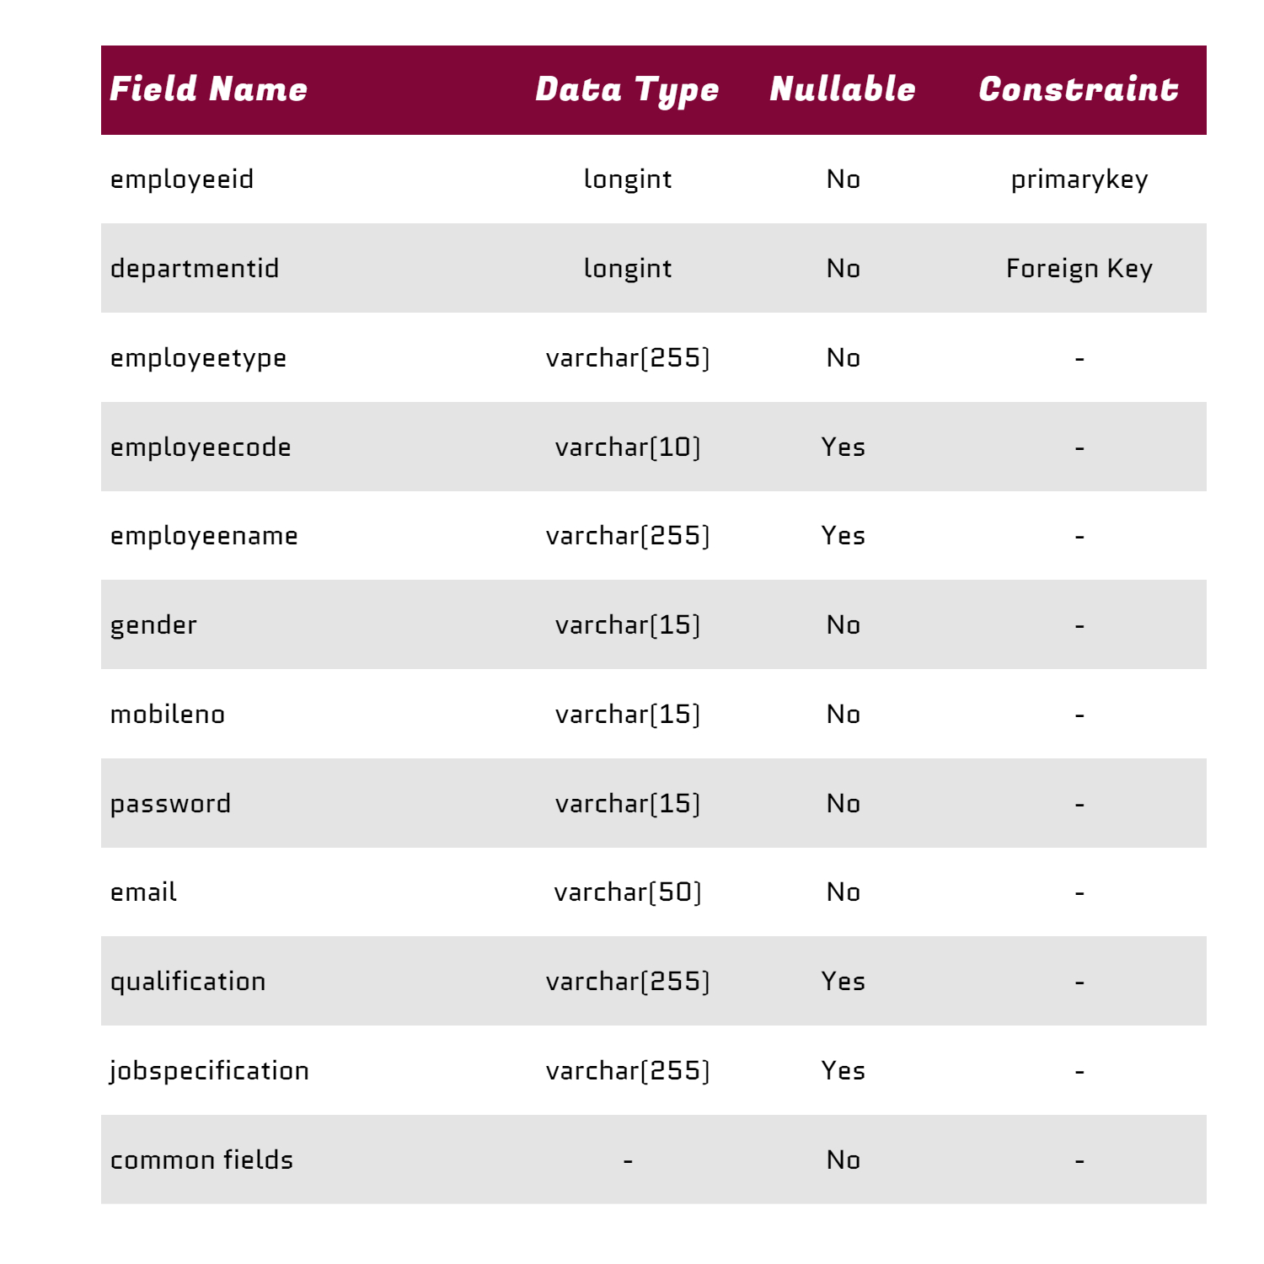

26

**Patient Table :**

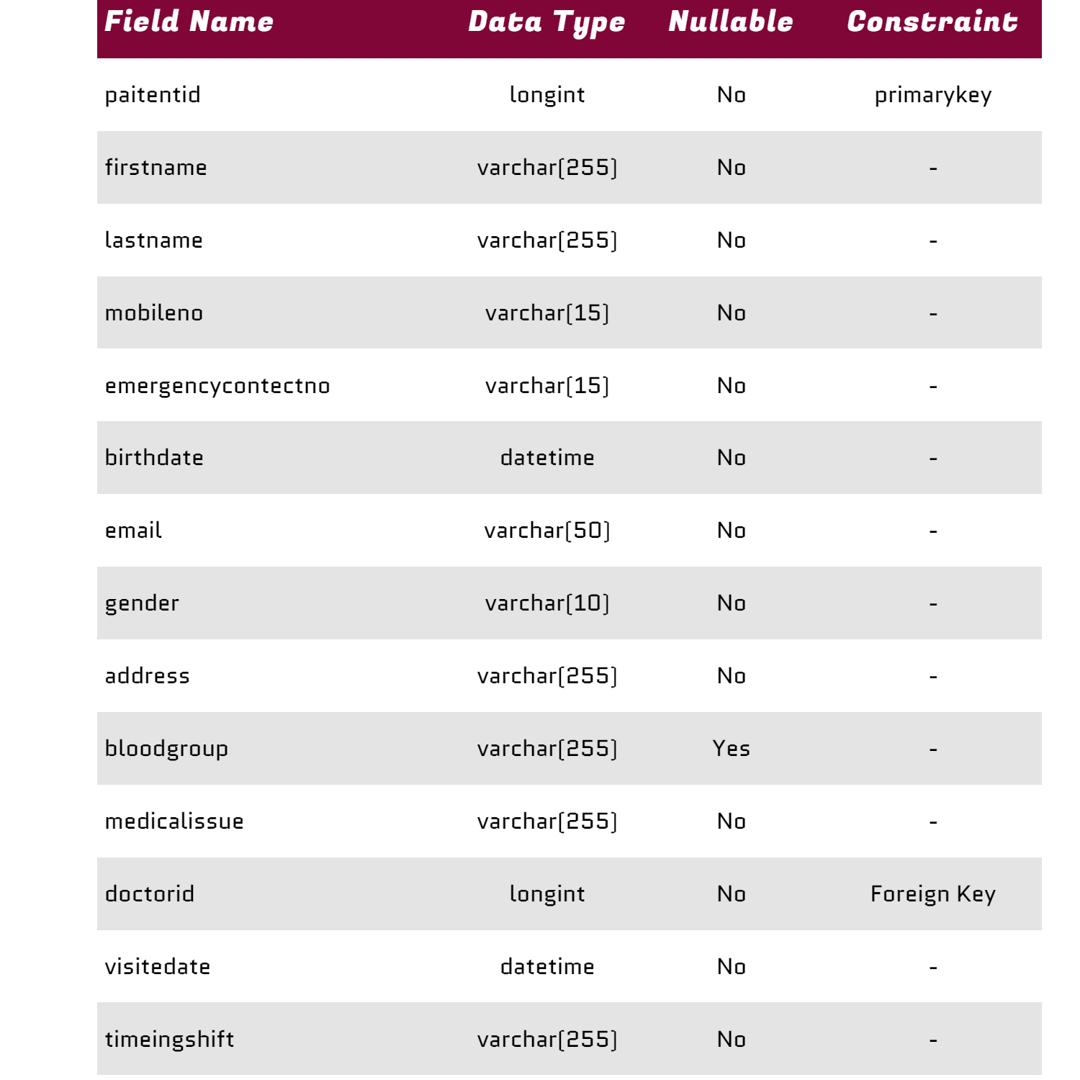

19

27

**Patient Table :**

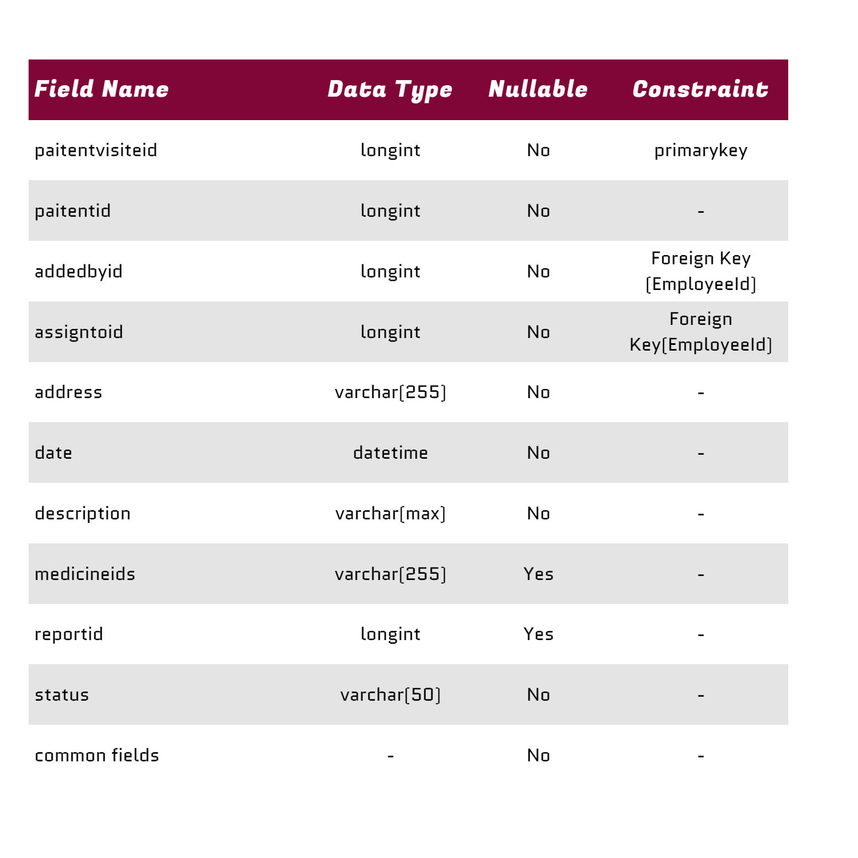

28

**Medicine Table :**

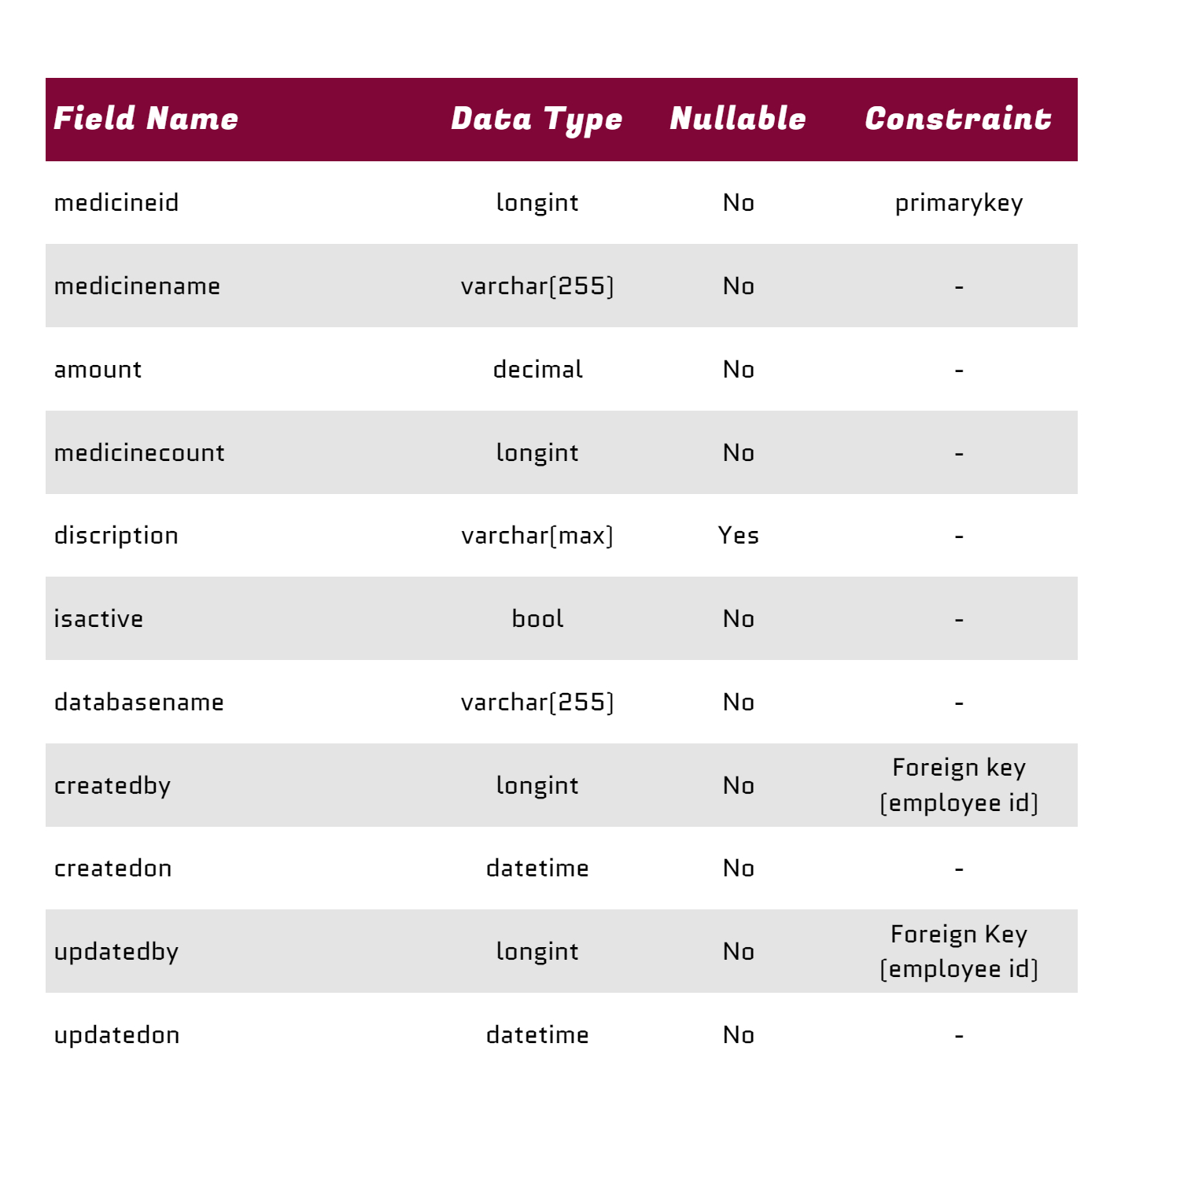

29

**Department Table :**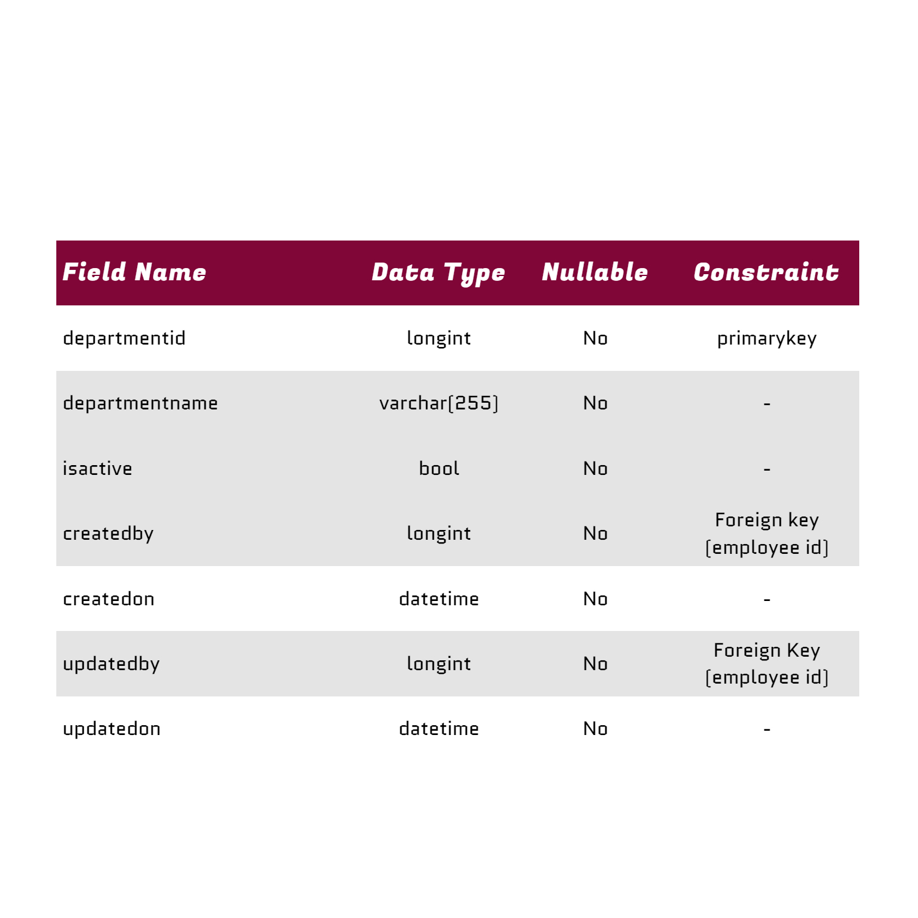

30

**Medicine Bill Table :**

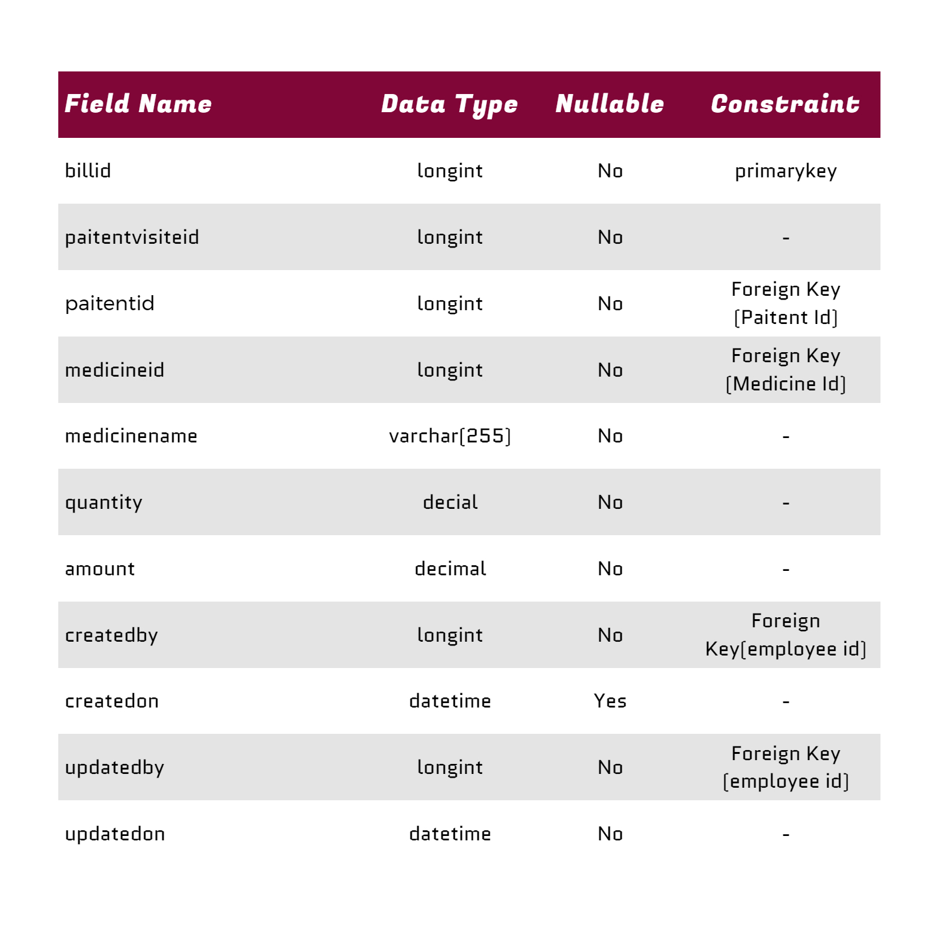

31

1. **. Development**

**Technology :**

1. **. Net core (API)**



**2). Angular (Frontend)**



1. **. SQL Server Management Studio (Database)**



32

1. **.Git Hub (Version Control):**



**Project Link : <https://github.com/chauhanchirag2241>**

33

**4.1).Coding Standards :**

Coding standards are a set of guidelines and best practices that developers adhere to when writing code. These standards ensure consistency, readability, maintainability, and reliability of the codebase. Here are some common coding standards that can be applied to the development of a hospital management system (HMS):

**Naming Conventions:**

* Use meaningful and descriptive names for variables, functions, classes, and other identifiers.
* Follow a consistent naming convention (e.g., camelCase, PascalCase, or snake_case) throughout the codebase.
* Avoid using single-letter variable names or cryptic abbreviations.

**Formatting and Indentation:**

* Use consistent indentation (e.g., tabs or spaces) to improve code readability.
* Choose a consistent code style for braces, spacing, and line breaks.
* Use whitespace to separate logical sections of code and improve readability.

34

**Comments and Documentation:**

* Include clear and concise comments to explain complex algorithms, business logic, or non-obvious code segments.
* Document public APIs, classes, and methods using documentation comments.
* Avoid redundant or unnecessary comments that do not add value to the understanding of the code.

**Error Handling and Exception Management:**

* Implement robust error handling and exception management mechanisms to handle unexpected errors gracefully.
* Use meaningful error messages and log error details for debugging and troubleshooting purposes.
* Follow consistent error handling patterns and avoid swallowing exceptions without proper handling.

35

**Molecularity and Re usability:**

* Design code in a modular and reusable manner to promote code organization, maintainability, and scalability.
* Encapsulate related functionality into separate modules, classes, or functions with well-defined interfaces.
* Follow the principles of separation of concerns and single responsibility to keep code units focused and cohesive.

**Code Documentation:**

* Document code thoroughly using inline comments, doc strings, or external documentation files.
* Include information about the purpose, usage, parameters, return values, and potential side effects of functions and methods.
* Update documentation regularly to keep it in sync with code changes and improvements.

36

**Version Control and Collaboration:**

* Follow version control best practices using a centralized repository (e.g., Git, SVN) to manage code changes, track history, and facilitate collaboration.
* Use meaningful commit messages and follow branching strategies to organize code changes and streamline collaboration among team members.

**Testing and Quality Assurance:**

* Implement unit tests, integration tests, and end-to-end tests to verify the correctness and reliability of the code.
* Adhere to testing best practices such as test-driven development (TDD), continuous integration (CI), and code reviews to maintain code quality and minimize defects.

**Performance Optimization:**

* Write efficient and optimized code to minimize resource consumption (CPU, memory, disk, etc.) and improve system performance.
* Profile code regularly to identify performance bottlenecks and apply appropriate optimizations where necessary.

By adhering to these coding standards, developers can ensure that the hospital management system is built with high quality, reliability, and maintainability, leading to a more robust and successful software product.

37

**4.2).Screen Shots :**

Patient Home Page

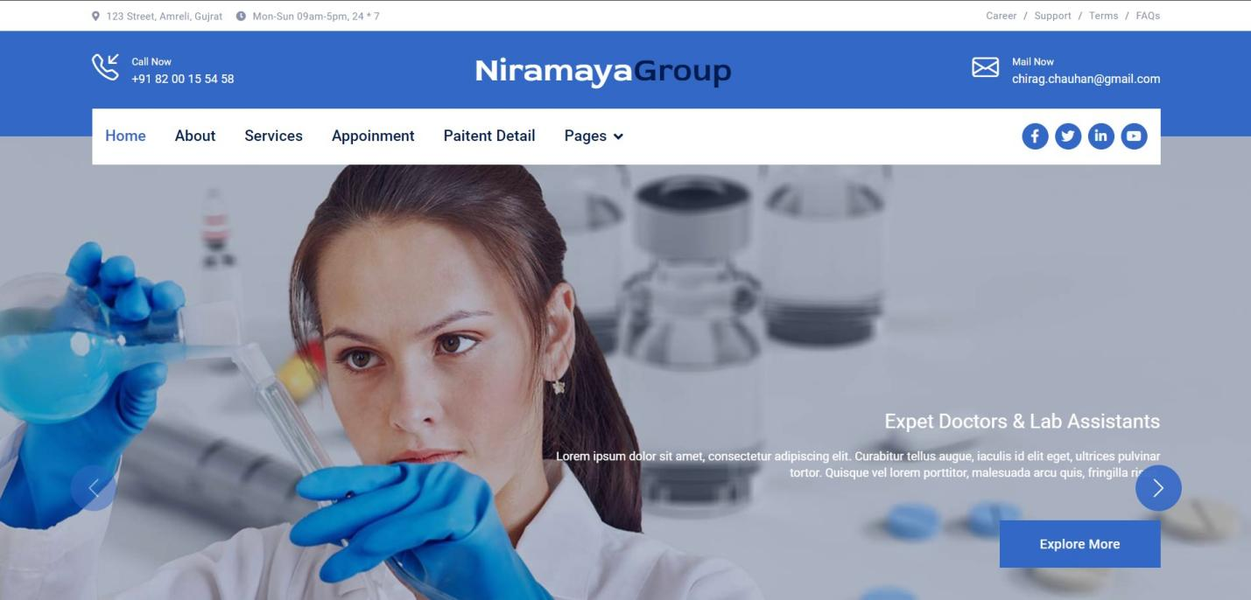

38

**Add Appointment Page :**

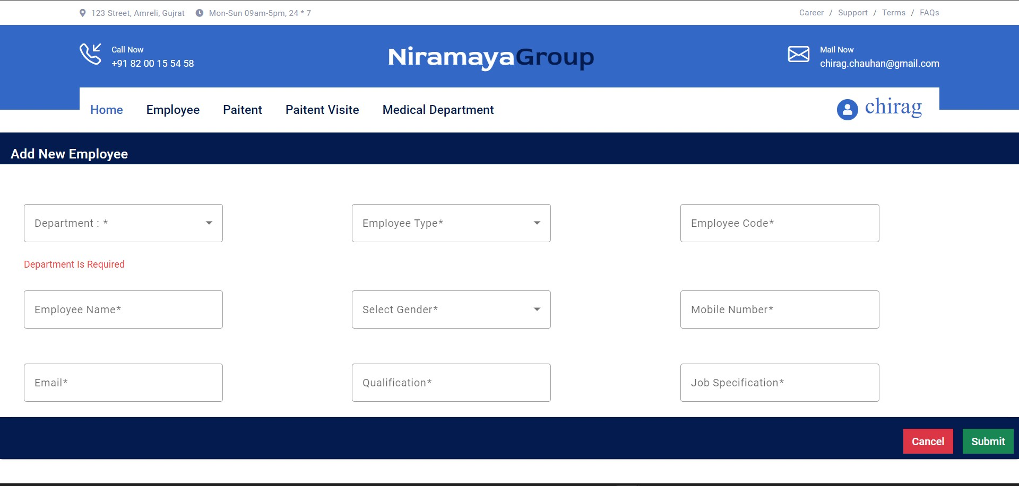

39

**Show Patient Detail Page :**

23

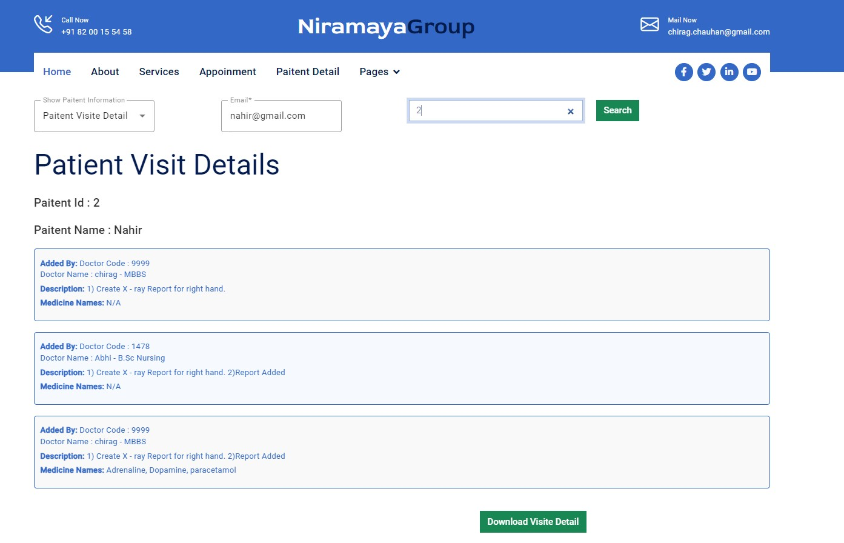

40

**Server Home Page :**

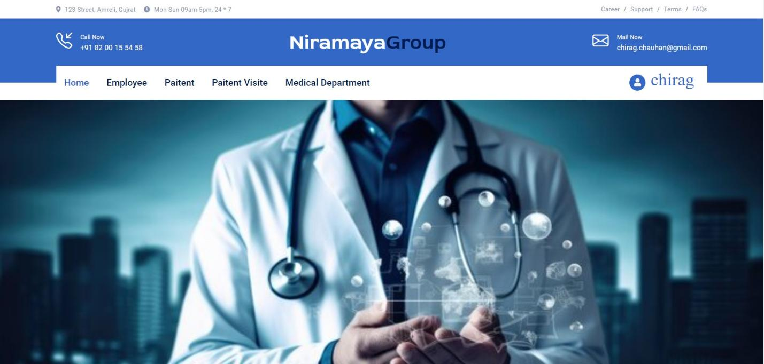

41

**Employee Page :**

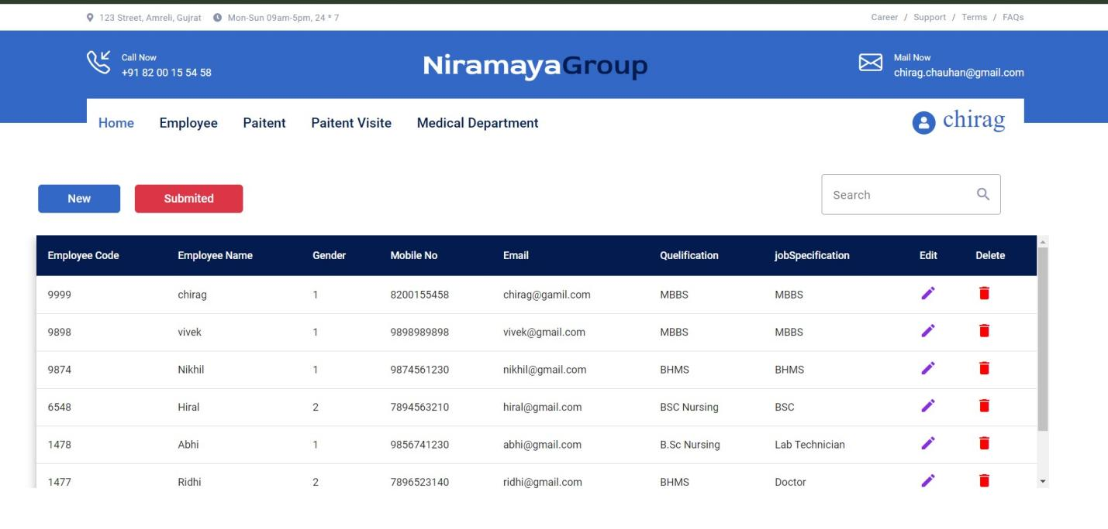

24

42

**Add Employee Page**



43

**Medical Department Page :**

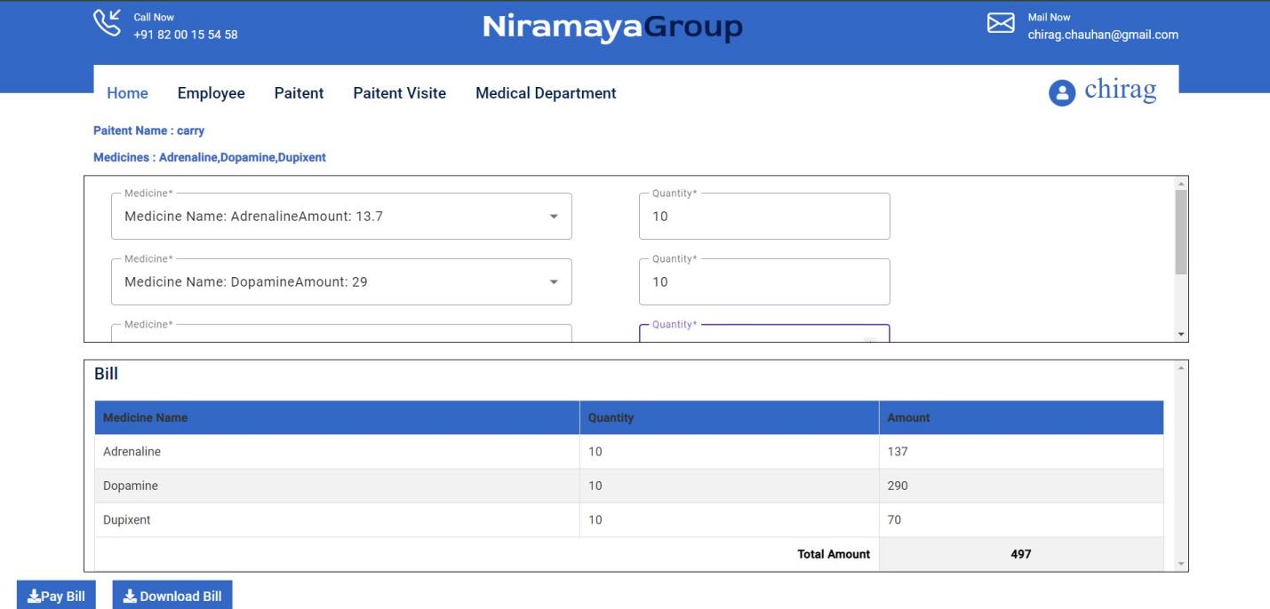

44

Feature Page :

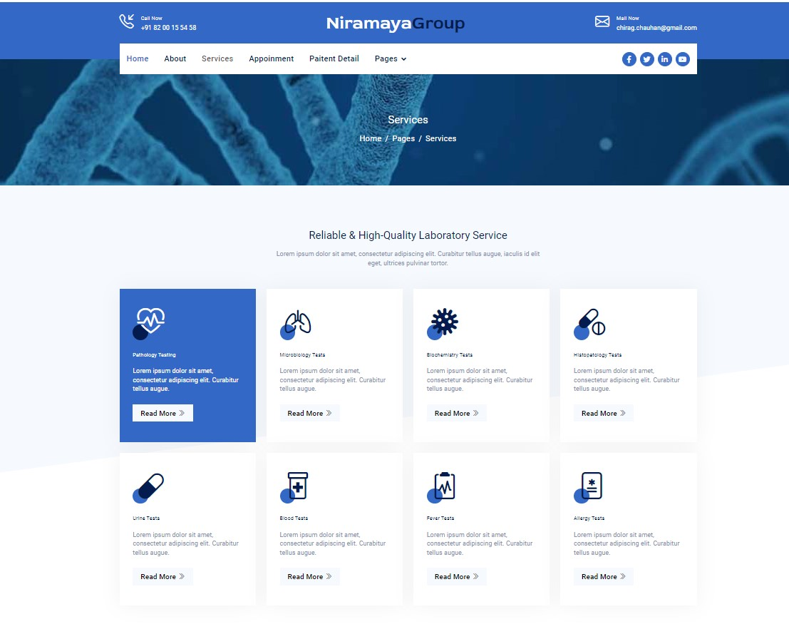

45

1. **. Proposed Enhancements**

Proposed enhancements for a hospital management system (HMS) aim to improve functionality, usability, efficiency, and overall user experience. Here are some potential enhancements that can be considered:

**Medicine Integration:**

* Integrate medicine capabilities into the HMS to enable remote consultations, follow-ups, and patient monitoring.

37

* Provide secure video conferencing, messaging, and file sharing functionalities within the system to facilitate virtual healthcare delivery.

**Mobile Application:**

* Develop a mobile application for the HMS to provide on-the-go access to patient records, appointment scheduling, medication reminders, and communication with healthcare providers.
* Ensure compatibility with iOS and Android devices and optimize the user interface for mobile usability.

46

**Predictive Analytic and Decision Support:**

* Implement predictive analytic and machine learning algorithms to analyze patient data, predict health outcomes, and identify at-risk patients.
* Provide decision support tools for healthcare providers to make informed clinical decisions based on data-driven insights and evidence-based guidelines.

**Internet of Things (IoT) Integration:**

* Integrate IoT devices such as wearable health monitors, smart beds, and medical sensors into the HMS to collect real-time patient data and monitor vital signs.
* Enable automatic data capture, remote monitoring, and alerts for abnormal health conditions to improve patient safety and proactive care management.

**User Experience (UX) Improvements:**

* Conduct usability testing and gather user feedback to identify areas for UX improvements in the HMS interface.
* Enhance navigation, layout, and visual design to create an intuitive and user-friendly experience for all types of users.

47

1. **. Conclusion**

In conclusion, the proposed enhancements for the hospital management system (HMS) represent a significant step forward in improving the efficiency, effectiveness, and user experience of healthcare delivery. By integrating medicine capabilities, developing a mobile application, implementing predictive analytic, enhancing patient engagement features, and improving interoperability, the HMS can evolve into a comprehensive platform that empowers healthcare providers, administrators, and patients alike.

These enhancements aim to address key challenges in healthcare delivery, such as remote patient care, proactive health management, data-driven decision-making, and interoperability between healthcare systems. By leveraging technology to its fullest potential, the HMS can streamline administrative processes, optimize patient care delivery, and improve patient outcomes.

In summary, the proposed enhancements have the potential to transform the hospital management system into a more agile, responsive, and patient-centered platform that meets the evolving needs of modern healthcare delivery. By embracing innovation and continuous improvement, the HMS can play a vital role in improving healthcare access, quality, and outcomes for patients around the world.

48

1. **.** Bibliography

**Websites:**

1. <https://chat.openai.com>
2. <https://Goggle.com>
3. <https://stackoverflow.com>
4. <https://csharpcorner.com>
5. <https://material.angular.io/>

49



50

37